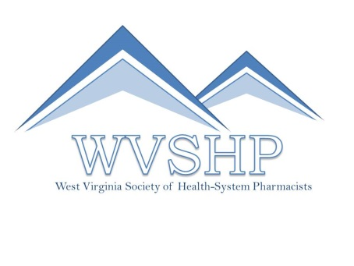

WVSHP 4th Annual Residency Showcase
WVU Health Sciences Centre, Pylons
October 20, 2018

8:30 am Welcome & Continental Breakfast, Table Set Up

9:00 am Preceptor Development Continuing Pharmacy Education: Precepting Pearls
Lisa Keller, PharmD, BCPS
Antimicrobial Stewardship Clinical Specialist
West Virginia University Medicine
Morgantown, WV

Learning Objectives:
- Discuss the four preceptor roles
- Compare feedback models
- Describe methods of incorporating learners into everyday practice

10:00 am Panel Discussion with Residents
Resident Panel Make-up TBA

11:00 am Residency Showcase

1:00 pm Lunch and Residency Program Director Panel
Director Panel Make-up TBA

3:00 pm Closing Remarks

Registration is free for all students. Students of all years are welcome to attend. Residency program registration is $150 per program. The deadline to register is by October 5th, 2018. There is a maximum of 5 representatives per residency program. Students should wear professional dress for the event.
West Virginia Society of Health-System Pharmacists

PO Box 590 / Culloden, WV 25510 / (304)696-7396 p / www.wvshp.org

Preceptor Development Continuing Pharmacy Education (CPE):
The preceptor development CPE is a knowledge-based activity describing preceptor development and skill growth for facilitating different levels of learners. The session (UAN: 0072-9999-18-103-L04-P) is approved for one contact hour (0.1 CEU) of CPE and is part of the registration fee.

Resident Panel Discussion:
Panel will consist of residents from a mix of program types and locations. Residents will cover topics geared toward students interested in residency, including resident life, being a competitive candidate, and any audience questions posed.

Residency Showcase:
Students will have the opportunity to walk around to the various tables for each program in attendance and ask questions, get more details about programs they’re interested in, and network with others.

Residency Director Panel Discussion:
Panel will consist of residency directors from a mix of program types and locations. Directors will cover topics geared toward students interested in residency, including interviewing, standout qualities of residents, and any audience questions posed.

CPE Accreditation Statement:

The West Virginia University School of Pharmacy (WVUSoP) is accredited by the Accreditation Council for Pharmacy Education (ACPE) as a provider of continuing pharmacy education. WVUSoP will report your participation in the program to NABP CPE Monitor within 4-6 weeks for all participants who successfully complete the session. Successful completion includes attending the entire session, signing the attendance sheet and completing an online evaluation form for the session. A statement of credit may be printed online at https://pharmacyce.wvu.edu/user/login.

